Sudoku is a classical logical game based on combinatorial number replacement puzzle. Objective is to to fill 9×9 matrix with digits so that each column, each row, and each box (3×3 sub-grid) of nine contain all of the digits from 1 to 9.

Solving sometimes can be a nagging process. For this purpose, here is the R helper function for you to solve this with R.

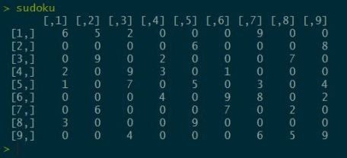

Let’s get the Sudoku grid we want to solve into R:

sudoku <- matrix(data=c( 6,0,0,2,1,0,0,3,0,

5,0,9,0,0,0,6,0,0,

2,0,0,9,7,0,0,0,4,

0,0,2,3,0,4,0,0,0,

0,6,0,0,5,0,0,9,0,

0,0,0,1,0,9,7,0,0,

9,0,0,0,3,8,0,0,6,

0,0,7,0,0,0,2,0,5,

0,8,0,0,4,2,0,0,9), nrow=9, ncol=9, byrow=FALSE

)

Now, we will need a function that will find all the 0 values – these are the values we need to work on.

get_zeros <- function(board_su){ #empty df

df <- data.frame(i=NULL,j=NULL) for (i in 1:nrow(board_su)){

for (j in 1:ncol(board_su)){ if (board_su[i,j] == 0) {

a <- data.frame(i,j) #names(a) <- c("i", "j") #df <- rbind(df, a)

df <- a return(df)

}

}

}

}

In addition we will need a function to solve and validated the solution.

Function validater will validate for the sudoku board a particular solution at a particular position:

validater(sudoku, 1, c(1,4))

In matrix, at position x=1, y=4, where there is 0, it will test if number 1 is valid or not. If the number is valid, it returns TRUE (number) to outer function for finding complete solution.

This function iterates through all the possible 0-positions and iterates through solutions that are still available based on the rules:

each row can contain only one number in range of 1..9 each column can contain only one numer in range of 1..9

each sub-grid of 3×3 can contain only one number in range of 1..9 And the nuts and bolts of the validater function:

validater <- function(board_su, num, pos=c(NULL,NULL)){ status <- FALSE

a <- as.integer(pos[1]) b <- as.integer(pos[2]) num <- as.integer(num) while (status == FALSE) {

for (i in 1:9) {

if ((board_su[a,i] == num & b != i) == TRUE) { status <- FALSE

return(status)

}

}

for (i in 1:9) {

if ((board_su[i,b] == num & a != i) == TRUE) { status <- FALSE

return(status)

}

}

#which box are we in

boxNx <- as.integer(ifelse(as.integer(b/3)==0, 1, as.integer(b/3))) boxNy <- as.integer(ifelse(as.integer(a/3)==0, 1, as.integer(a/3)))

#looping through the box

for (i in boxNy*3:(boxNy*3 + 3)) {

for (j in boxNx * 3 : (boxNx*3 + 3)) {

if ((board_su[i, j] == num & i != a & j != b) == TRUE){ status <- FALSE

}

}

}

status <- TRUE return(status)

}

}

With the following solution:

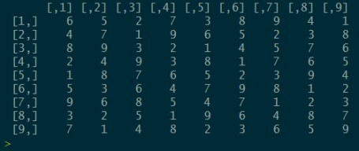

For sure, this is not to be taken seriously, as you get the application on your mobile phone where you make a photo of your grid to be solved and the phone solves it for you, using library like OpenCV.